Indent Validation Service
Production Architecture, Integration & Data Flow
Version 1.1 (Draft)

Contents
Right-click and select "Update Field" to generate the table of contents.

1. Executive Summary
The Indent Validation Service is a stateless service that integrates with IPMS to evaluate procurement indents and return an adequacy score together with a detailed analysis. It is invoked when a user selects the “Check Adequacy” action on an indent in IPMS.
This document focuses on production integration: the APIs the service exposes and consumes, the database tables IPMS must create, the system architecture, and the runtime data flow. The internal analysis logic is summarised only briefly, as it is not the integration concern.
The service does not store data. It receives an indent identifier, gathers the indent's field data and document attachments, analyses them, and returns a structured response. IPMS persists the response — the score and the full detailed analysis — and manages all history and display.
Advisory, not blocking. The adequacy score is guidance, not a gate. Users may submit at any score. Both the user and the manager see the same detailed analysis.
The system has two subsystems:
- Live Validation API — handles each request, returns results, reads the standard from memory, never writes to the database.
- Offline Standard Pipeline — scheduled; rebuilds the standard from accumulated indents and publishes a new version to the database.
LLM access. All language-model calls are made through an authenticated GENAI API over an authenticated session.

2. API Contracts
This section defines every integration point. Each contract is described as a field table: the key name, its data type (string, number, boolean, list, or object), and its meaning.

APIs required
The integration involves one API the service exposes and three it consumes:
API | Direction | Purpose
Check-Adequacy API | IPMS → Service (exposed by us) | Receives the request, returns the scored analysis
Indent Field API | Service → IPMS (consumed) | Provides the indent's filled field data
Document Store API | Service → Store (consumed) | Provides the indent's attachments via OAuth
GENAI API | Service → GENAI (consumed) | Performs extraction and analysis (authenticated)

2.1 Check-Adequacy API — request
POST /check-adequacy — body is an object:
Key | Type | Description
indent_id | string | Identifier of the indent to validate
domain | string | Indent domain (selects the standard)
callback_url | string | Where the result is delivered when ready (async)
Immediate response (before analysis completes) — an object:
Key | Type | Description
analysis_id | string | Identifier for this analysis run
status | string | Processing state (e.g. processing)

2.2 Check-Adequacy API — result
Delivered when analysis completes. This is the full payload IPMS persists — the score and the complete detailed analysis. An object with these keys:
Key | Type | Description
analysis_id | string | Identifier for this analysis run
indent_id | string | The indent that was analysed
domain | string | Indent domain
analysis_timestamp | string | When the analysis ran (ISO timestamp)
standard_version | string | Which standard version was used
score | number | Overall adequacy score, 0–100
grade | string | Strong / Adequate / Needs Improvement / Weak
score_breakdown | object | Points per category
findings | list of objects | Each: category, status, title, detail
recommendations | list of strings | Actions to improve the indent
missing_documents | list of strings | Required document types not found
interrelationship_issues | list of strings | Cross-document inconsistencies
document_inventory | list of objects | Each: file, classified_as, genuine (boolean)
Detailed analysis stored with the score. IPMS persists the entire detailed analysis alongside the score, so the user and manager always see the full reasoning, not just the number.

2.3 Indent Field API — consumed
Returns an object with indent_id and fields, where fields is a list of objects — one per filled field:
Key (per field object) | Type | Description
question | string | The field label shown to the user
answer | string | The value selected or entered
required | boolean | Whether the field was mandatory (the * fields)
Dynamic fields. Fields are conditional — selecting one option unlocks others — so the key set varies between indents. The service consumes whatever question / answer / required entries are returned; new or renamed fields do not break it.

2.4 Document Store API — consumed
Returns the indent's attachments over an authenticated (OAuth) connection: a list of files (binary content plus original filename). Filenames are arbitrary and are not relied upon — each file's true type is determined internally.

3. Database Design
The Validation Service does not write to the database. IPMS persists the service's response and manages history. This section defines the tables IPMS must create.

Tables required
Table | Purpose
indent_analysis | Stores every analysis run — score plus full detailed analysis; history with a latest flag
indent_feedback | Stores user / manager feedback on findings, used offline to improve the service
validation_standard | Stores the versioned best-practice standard per domain, read by the service at startup

3.1 indent_analysis
Stores the score and the full detailed analysis. History is preserved by keeping all rows; the latest per indent is flagged for display.
Column | Type | Notes
analysis_id | string | Primary key
indent_id | string | Indexed; links to the indent
domain | string | Indent domain
analysis_timestamp | datetime | When analysis ran
score | number | 0–100
grade | string | Strong / Adequate / Needs Improvement / Weak
score_breakdown | object (JSON) | Per-category points
findings | list (JSON) | Detailed findings
recommendations | list (JSON) | Recommended actions
missing_documents | list (JSON) | Required-but-absent document types
interrelationship_issues | list (JSON) | Cross-document inconsistencies
document_inventory | list (JSON) | Classified documents + genuine flags
standard_version | string | Which standard version was used
is_latest | boolean | True for the most recent per indent
full_response | object (JSON) | Complete response, for audit
How “latest only” works. On a new analysis for an indent, set is_latest = false on all prior rows for that indent_id, then insert the new row with is_latest = true. Display filters on is_latest = true; history returns all rows by timestamp.

3.2 indent_feedback
Captures user / manager feedback on findings — read offline to improve prompts and correct the standard. Each row links to an analysis.
Column | Type | Notes
feedback_id | string | Primary key
analysis_id | string | Links to indent_analysis
indent_id | string | Indexed
domain | string | Indent domain
feedback_timestamp | datetime | When feedback was given
feedback_type | string | finding_wrong / finding_correct / severity_wrong / missing_finding
finding_category | string | mandatory / documentation / risk / vendor / approval
finding_title | string | The finding being commented on
user_comment | text | Free-text explanation
correct_value | text | What the user says is correct (optional)
submitted_by | string | User or manager identifier

3.3 validation_standard
Stores the versioned best-practice standard per domain. The service loads the current version into memory at startup and reloads when a new version is published.
Column | Type | Notes
standard_id | string | Primary key
domain | string | Indent domain this standard applies to
version | string | Version label (e.g. v4-2026-06)
published_timestamp | datetime | When this version was published
standard_body | object (JSON) | The full standard content
is_current | boolean | True for the active version per domain

4. High-Level Architecture
The diagram below shows the two subsystems and their integration points. Solid lines are runtime request flows; dashed lines are the offline standard-publishing flow. The Validation Service is stateless except for the in-memory standard.
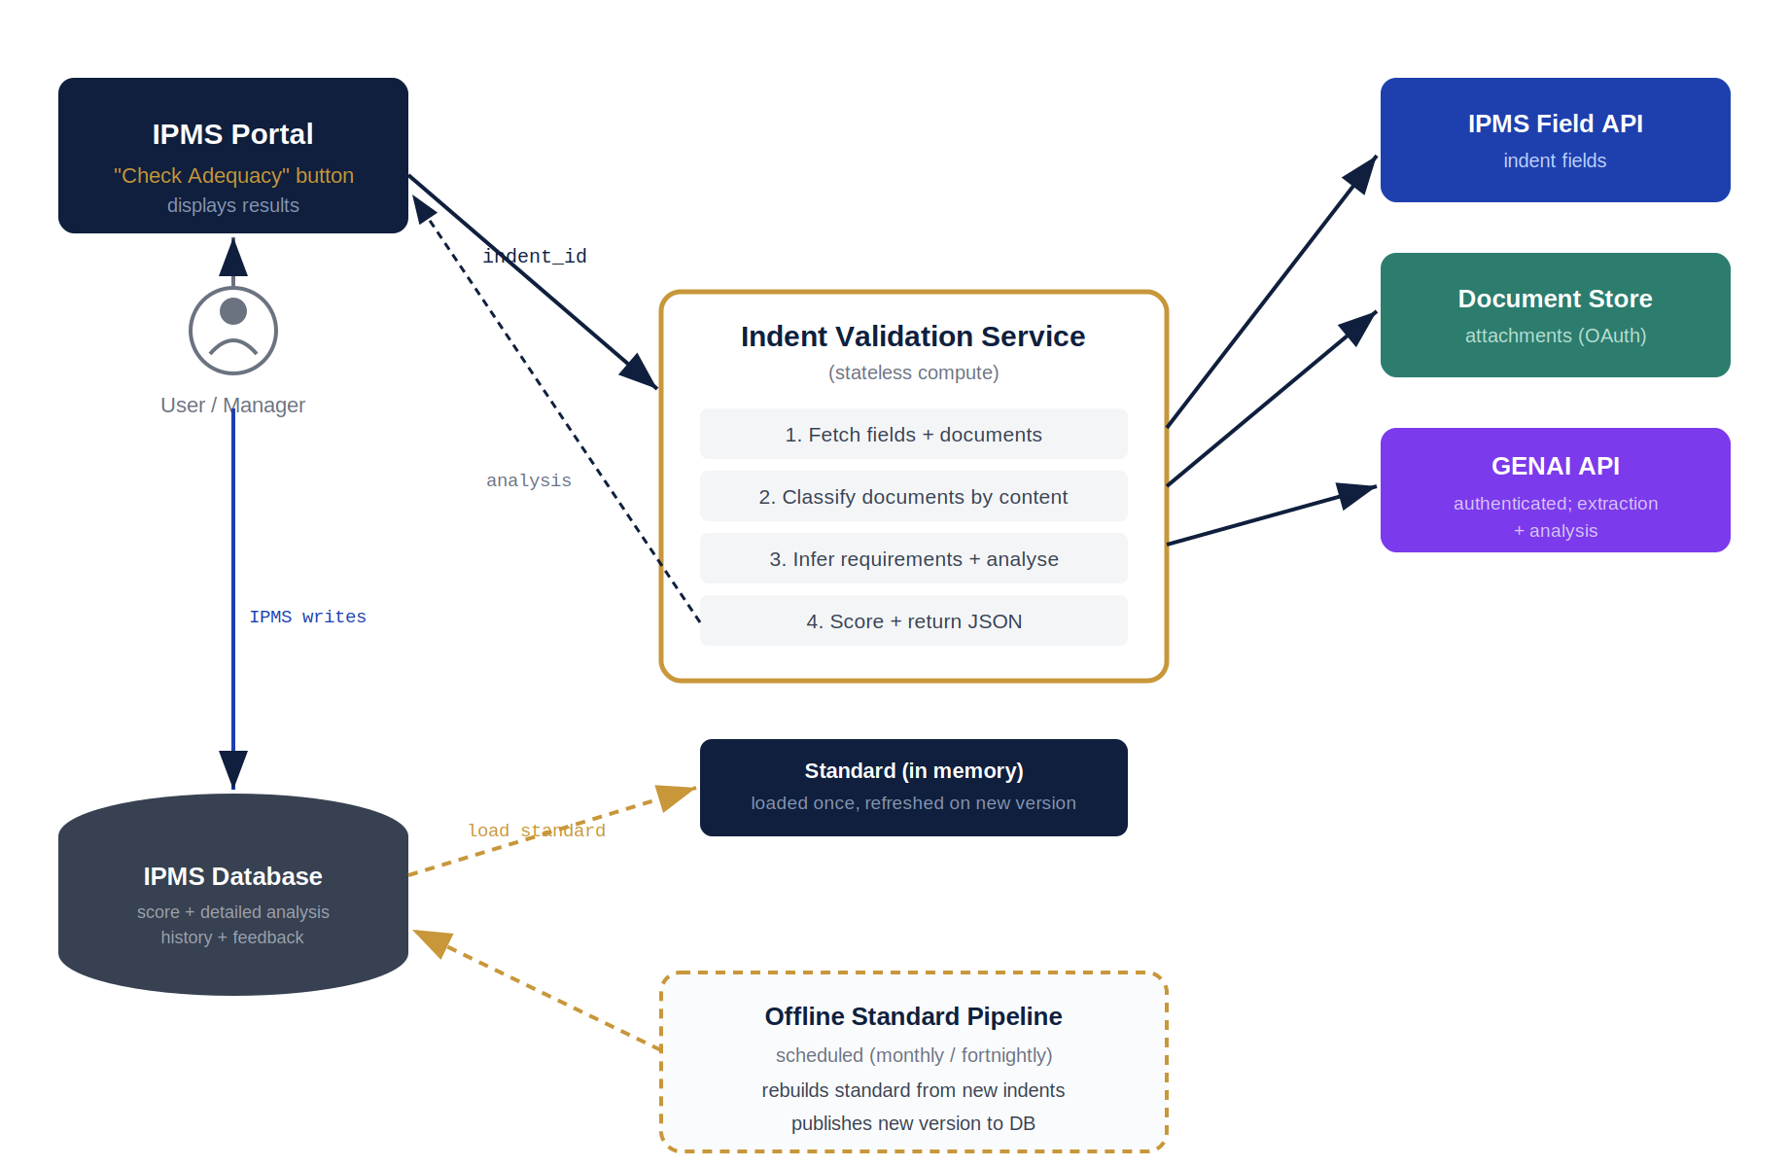
Figure 1 — High-level architecture. The service fetches indent fields and documents, calls the GENAI API, and returns a scored analysis to IPMS, which persists it.
Four systems participate:
System | Role | Integration
IPMS Portal | Triggers analysis, displays results, owns the database | Calls the Check-Adequacy API; persists the response
IPMS Field API | Source of indent field data | Service fetches question / answer / required entries
Document Store | Source of attachments | Service fetches files via authenticated OAuth
GENAI API | Extraction and analysis | Service sends prepared content over an authenticated session
Statelessness. The service holds no persistent indent state. Each request is self-contained: fetch, analyse, return, forget. The only in-memory state is the current standard, loaded at startup and refreshed on a new version.

5. Data Flow — “Check Adequacy”
This is the runtime path, triggered each time a user selects “Check Adequacy”. It is asynchronous: the service acknowledges the request immediately and delivers the result when analysis completes.
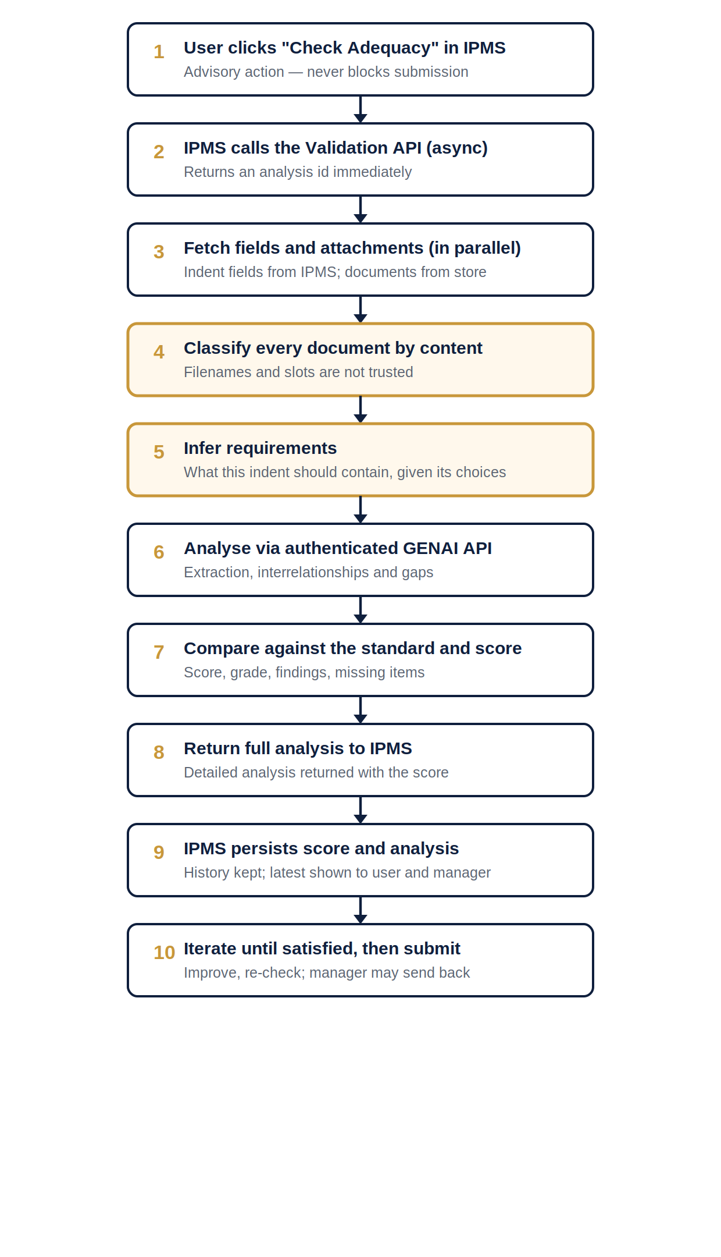
Figure 2 — End-to-end “Check Adequacy” flow. Steps 4 and 5 (highlighted) are handled internally by the service.

5.1 Internal Analysis Steps (Summary)
Steps 4 and 5 are performed inside the service and are not integration concerns. In brief:
- Classify documents by content — attachments are identified by what they contain, not by filename or upload slot, and verified as genuine.
- Infer requirements — the service derives what the indent should contain from the field selections, then checks the actual content against that.

5.2 The Iteration Loop
Because the score is advisory, users iterate. Each “Check Adequacy” produces a new analysis. IPMS stores every analysis but displays only the latest for each indent, to both the user and the manager.
Check Adequacy -> lower score -> detailed gaps shown
user improves attachments / fills fields
Check Adequacy -> higher score -> fewer gaps
user submits when satisfied (at any score)
Manager reviews the same detailed analysis (latest only)
manager may accept, or send back for improvement

6. Standard Storage & Refresh
The best-practice standard is the benchmark every indent is measured against. It is stored in the validation_standard table and its lifecycle is separated from live traffic.
- Stored as a versioned record per domain (validation_standard table).
- Small and changes rarely.
- The live service loads the current version into memory at startup.
- The service periodically checks for a newer version and reloads if found — a rebuild takes effect without redeployment.
No per-request database access for the standard. Because the standard lives in memory, comparison is instant. The database is touched only at startup and on version change — never on the critical path of a request.
The offline pipeline rebuilds the standard on a schedule (a hybrid trigger: rebuild when 15 new quality-passed indents accumulate, or 30 days pass, whichever is first), then publishes a new version to the validation_standard table. Each analysis records the standard_version it used, so past scores remain reproducible.
End of document — Indent Validation Service, Architecture, Integration & Data Flow v1.1 (Draft)

